### Feedback

The functionality available on the **Feedback Viewer** screen allows administrative users to receive messages about the system from other users. These messages provide a forum for users to ask questions, report problems, or offer suggestions regarding use of the webclient and the HIE system.

Each screen of the webclient provides a **Provide Feedback** link in the upper right-hand corner.



Once a user clicks on the **Provide Feedback** link, they will be shown a feedback message window. 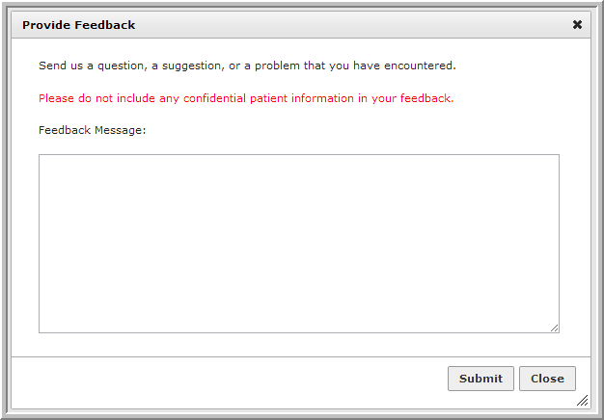

Each message will automatically include information about the page and/or patient currently being viewed by the submitting user. The user should not include patient demographics or other identifying information in the body of their message**.**

Administrative users with the appropriate rights will be able to browse all feedback using the **Feedback Viewer**. Feedback messages can be filtered using a date range, user ID, keyword, or webpage name.

Once a filter is applied, a table of matching feedback messages will be generated to the right. Each message listing includes a timestamp, the web address identifying the page about which feedback was left, any message from the submitting user, the submitting user’s login and name, and associated patient information, such as MRN.

